1. **Introduction** 
   1. **Statement of the problem** 
      1. **General Problem**

**How to aid students to engage basic technical computer programming lessons in a more comprehensive yet entertaining way?**

In order to successfully learn about something doesn’t only require academic skills but it also requires full interest of the learner. In fact according to John Dewey’s theory of interest in education, it plays a big part in anyone’s learning ability about a certain topic. Without developing an interest to the lesson, it would be almost impossible for the learner to absorb the essence of the topic.

One of the course/subjects that suffers with learner’s loss of interest is computer programming. Computer programming lessons is composed of highly technical terms and concepts that, most of the time, intimidates students and cause them to flee from the lessons. These concepts require practical understanding or application in order for students to absorb its core ideas.

* + 1. **Specific Problems**

**How non-academic virtual games consume young learners’ opportunity to learn?**

Virtual games have been one of the most time consuming past times of our generation. Unlike the past generations, gadgets are most accessible in our times for any ages. ‘Pinoy’ conventional team building games like ‘Tumbang Preso’, ‘Luksong Baka’ and etc., has been replaced by virtual games. Currently [percentage of STI computer students that is hooked with virtual games] of STI students with computer related course consumes more than 5hrs playing virtual games. Virtual games consume the time that they should’ve been spending with their studies. As a result, more and more students neglect their studies and lose their interest for it.

**How the intimidations from technical computer programming ideas affect learner’s performance?**

Due to computer programming’s technicality, many students fail to perform well. Learners are being overwhelmed by the technical terms used in programming lessons that is why they easily lose their interest in the discussion. Most of the students fail to see the practical sense of the lessons because they seldom see how the logic works. As a result some students totally lose interest in studying programming and some, misinterprets the situation to be inability to comprehend with the lesson.

**How technical concepts technical terms make it hard for new young learners to understand basics of computer programming?**

Computer programming is composed of collective technical terms that most of the time overwhelms new learners. Scenarios like these sometimes make it hard for the learners to follow the lesson. It makes it harder for them to cope with the succeeding lessons because of they haven’t yet understood the logic of the previous lessons.

**How to introduce basic computer programming technical concepts to non-IT related students/professionals?**

In one of his interviews, Steve Jobs stated that, “Everybody in this country should learn to program a computer, because it teaches you how to think.” Almost everything we do today requires a bit of programming logic. Being non-IT personnel also needs to understand even the basic of computer programming in order to ease daily the operation of most computer software like Spreadsheet, Photo editor, TPS and etc.

**How independent learners find it hard to know where to start in studying basic computer programming?**

Self-taught programmers have a great contribution in professional programmers’ population. As an independent learner, sometimes it would be very confusing to know where to start and what necessary lessons should be considered. Looking for relevant tools to understand the basic concepts of computer programming can be very time consuming and sometimes it scares away learners when they have been tangled in its numerous over-whelming topics.

* 1. **Current State of Technology**

According to ESA, “35% of games played worldwide are on smartphones”. Smartphones are utilized by different operating systems such as android, IOS, windows and etc. These devices use touchscreen technology, as it’s basic navigation. Games designed for smartphone uses different styles of controls. Examples are analog swipes, swipes to move, touch, commands and etc.

Video games have many varieties of genre like puzzle, educational, strategy, first-person shooters, war, artillery and many more. Puzzle games are one of the most played games in smartphones. Some examples are 2048, Tetris, The Room, Candy Crush Saga, Cut the Rope, Lightbot and etc. One of a good example of puzzle game is Lightbot. Lightbot is a puzzler that teaches kids concepts used in computer programming. An undergraduate student who’s been coding since he was a kid himself developed this programming app for kids. Brief instructions are included at the beginning of each level - what you need to know when you need to know it. The level of challenge ramps up very quickly, making this best suited for older kids and teens. This game made programming basics more entertaining to learn for users who just intended to play a mobile game.

**Lightbot Screenshots:**

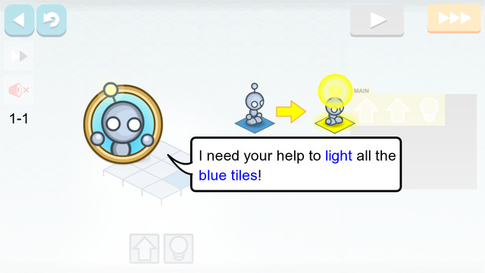

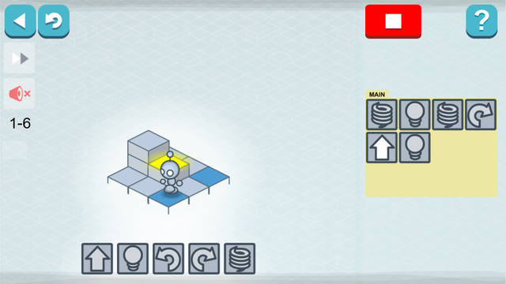

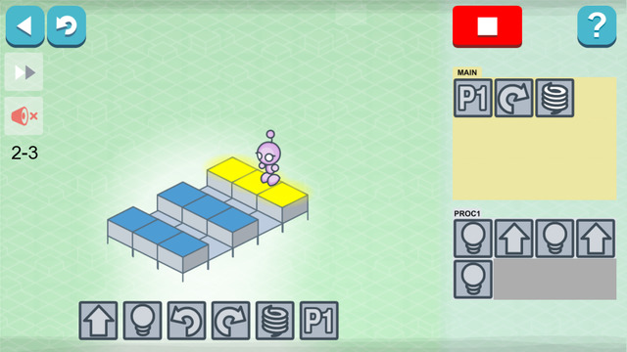

* 1. **Objective of the Study**
     1. **General Objective**

**To develop a game that is logically challenging without compromising the entertainment of mobile gamers.**

One of the reasons why video games have been invented is to entertain its consumers. The main objective of the game is to develop a game that would logically challenge gamers in the most entertaining way the proponents could offer.

* + 1. **Specific Objectives**

**To design a game that will capture the interest of gamers with age bracket of 9 and above.**

The game will be designed to accommodate the age bracket of 9 years and above. It aims to be simple yet still logically challenging in order to enhance their logical capability.

**To develop a game concept that will avoid monotonous game flow.**

Quests and levels that offer different challenges and character abilities will be develop to produce a game flow that is dynamically progressing. Proponents will also develop the story line to be relevant and interesting to give more spice and meaning to the gameplay.

**To develop a game that will enhance gamers' logical thinking without excessive alert messages, tutorials and notification pop-ups.**

Stage tutorials and alerts will be minimal for this game in order to let the gamer focus more on the challenges at hand to their current levels.

**To develop a game that could introduce basic programming concepts without compromising the entertainment of the gamers.**

Game challenges and skills will be based on basic computer programming concepts that would be simplified to non-IT technical gamers to comprehend. Technical terms will also be replaced by layman’s term to eliminate intimidation from the gamer’s side. These basic programming concepts will also be injected in areas of the story, skills and challenges that will be explained at the explained at the end of each stage.

* + 1. **Scope and Limitations**

**Scopes**

**Main Menu**

The module will allow users to choose between  series of options for the game.

**Game Story**

This game will run through the flow of a story.

**Game Modes:**

**Story Mode**

This mode will be guided by a specific story  as the basic programming concept lesson and game progress.

**Mission Mode**

This mode will enable the player take on  additional quests while practicing and addressing additional lessons of basic computer programming concepts.

**Sand Box**

This mode will enable the player to try and  perform experiments with the commands/skills he/she gained though the lessons.

**Basic Computer Programming Concepts**

The game has a feature of posting lessons to explain skills, quests and tools depending on the unlocked stages of the player.

**Viewing of Chosen Set of Commands as Pseudocode Value**

This module will enable the player to view the pseudocode value of the commands already in use in the current level.

**Logical Compilers**

This module will serve as a compiler for the commands that are combined by the gamer. It will allow the user to check for instructions that are not logically executable. Before executing, he will first have to check if there is any logical errors or conflict within the gamer’s chosen set of commands for the Lightbot. If the compiler found any error, alerts messages will be prompted to inform the gamer. These prompt messages will be executed by the gamer through ok button.

**Stages:**

**Tutorial Stage**

This stage will serve as a tutorial for the gamer to understand the mechanics of the game. All necessary rules, instructions and commands to begin with the game will be explained in this stage. Tutorial stage will be implemented in a computer table environment.

**Stage 1**

After being instructed by the game, the microbot  will then enter the CPU case and begin in the motherboard as the stage’s environment

**Stage 2**

Stage 2 will be provided with an environment of the  hard disk of a computer.

**Stage 3**

Stage 3 will be implemented in the video card of the  computer.

**Stage 4**

Stage 4 will designed with the environment of the  central-processing unit (CPU).

**6 Levels**

For every Stage  Each stage is composed of 6 levels that escalate the game’s difficulty in order to practice the newly learned commands or skills.

**Computer repair tools**

The game will use computer repair tools that will be  necessary to solve the problems in the game.

**Save Multiple Games**

Players are enabled to save 5 game statuses.

**Background Music and Sound Effects**

The gameplay will be accompanied by a  background music that will make the game more thrilling.

**Offline**

This game is designed for offline use.

**Single Player**

This game only caters a single player mode.

**Command Count (Per Level and Per Stages)**

As the player proceeds to higher levels and stages,  his/her commands will be recorded.

**Award (Medal)**

Medals will be awarded if the player compiled less than or equal to the number of maximum commands indicated per level.

**Inventory**

Inventory in a form of backpack that is composed of different compartment, which can only contain specific tools. The character, to solve problems and proceed to next stages, can use these tools.

**Character modification**

The player can choose the gender of his/her  character at the beginning of the game.

**Skills**

The character could learn new set of skills that could be helpful to solve each game levels. These skills are integrated with basic computer programming concepts that will help the gamer to understand real life computer programming.

**Stats**

The game has the ability to display the gamer’s performance depending on time, number of commands used and accuracy of commands that is set. It can display the summary of the gamer’s performance.

**Account**

Accounts are saved locally in the gamers mobile to  save current game state.

**Limitations**

**Online**

The developers will not cover the development of online game play. The game will be played offline.

**Multiplayer**

The game will not handle the more than 1 player in  the game.

**In game transaction**

The game will not have any in game transaction for the character or player.

**High Scores**

The ability of the gamer to solve the games challenges will not be based on high score. Thus the game will not provide a high score feature for the player.